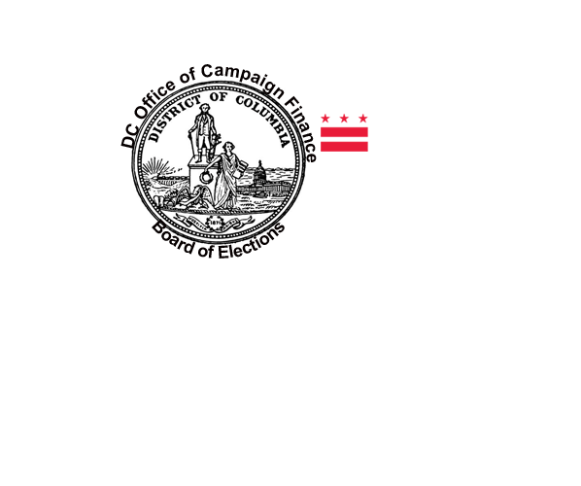**OFFICE OF CAMPAIGN FINANCE**

**WASHINGTON, D.C. 20003**

**FAIR ELECTIONS PROGRAM**

**SEVENTEEN CANDIDATES HAVE REGISTERED UNDER THE FAIR ELECTIONS PROGRAM (FEP)**

